 

Project and Professionalism

(6CS007)

Project Proposal Report

Home Rental System

|  |  |
| --- | --- |
| Student Id | : 2358569 |
| Student Name | : Amit Babu Khatri |
| Group | : LUCG19 |
| Supervisor | : Mr. Johan Tandukar |
| Reader | : Mr. Aatiz Ghimire |
| Cohort | : 9 |
| Submitted on | : 1/12/2024 |

**Acknowledgement**

My sincere gratitude goes out to everyone who helped and advised me during this process. I want to start by sincerely thanking my supervisor, Mr. Jhon Tandukar, and one of my readers, Mr. Akash Adhikari, for their unwavering support and inspiration. Their insightful comments and recommendations were crucial to this project's successful conclusion.

I would especially want to thank Mr. Jhon Tandukar, my supervisor, for his openness to discuss and endorse this issue as well as for his constant support and direction during the assignment. I also like to express my gratitude to Mr. Aatiz Ghimire for his support and encouragement during the project.

Table of Contents

1. Statement of Project Details 1

1.1 Project Title 1

1.2 Academic Question 1

1.3 Aims 2

1.4 Objectives 2

1.5 Artefact (proposed) to be developed (in brief) 2

2. Project Proposal 4

2.1 Introduction 4

2.1.1 Problem scenario 5

2.1.2 Project as a Solution 5

2.2 Initial Research into sources of information 6

2.3 Artefact (Proposed): Home Rental System ............................................................................ 3

2.3.1 WBS ................................................................................................................................ 3

2.3.2 Overview ......................................................................................................................... 3

2.3.3 Justification and Relation to Academic Question ............................................................. 3

2.3.4 Consideration of Other Artefacts ..................................................................................... 4

2.3.5 Full Details of the Artefact ............................................................................................... 5

2.3.6 Development Approach ................................................................................................... 5

2.3.7 Methodology Justification ................................................................................................ 6

2.3.8 Tools and Techniques ...................................................................................................... 6

2.3.9 System Testing ................................................................................................................ 7

1. Plan/Schedule ............................................................................................................................. 8

3.1 Gantt Chart ............................................................................................................................ 8 References ...................................................................................................................................... 9

**Table of Figures**

Figure 1: Basobaas ......................................................................................................... 7

Figure 2: Reality Nepal .................................................................................................... 8

Figure 3: Trulia ................................................................................................................ 9

Figure 4: NepalHomes .................................................................................................. 10

Figure 5: Rentals ........................................................................................................... 11

Figure 6: Similarity Check ............................................................................................. 12

Figure 7: WBS ............................................................................................................... 13

# 1. Statement of Project Details

## 1.1 Project Title

As technology rapidly advances worldwide, Nepal's housing market has struggled to keep pace. Outdated, paper-based leasing procedures have led to issues such as data loss and miscommunication between landlords and tenants. To address this, I propose the development of a user-friendly rental property management website. This digital platform aims to benefit both landlords and tenants by improving efficiency, ensuring data integrity, increasing transparency, and enhancing accessibility. It would also contribute to the scalability and modernization of the housing sector in Nepal. The creation of this website requires careful planning, with special attention to security and privacy considerations..

## 1.2 Academic Question

1. How would you provide efficient search and filtering tools to assist consumers in finding rental properties that meet their needs?
2. What ethical principles and data privacy safeguards should be integrated into the system to protect the personal information of both property owners and renters?
3. How can advanced analytics, such as predictive algorithms or machine learning, be integrated into the system to provide personalized property recommendations based on user preferences and behavior?
4. How can the system incorporate basic communication tools, such as messaging or inquiry forms, to facilitate seamless interaction between property owners and potential renters?

## 1.3 Aims

* Create an easy-to-use web platform to simplify the process of finding, renting, and managing rental properties for tenants and landlords.
* Modernize Nepal's rental system by using digital solutions to improve efficiency, reduce paperwork, and minimize administrative costs.

## 1.4 Objectives

* Digitize the rental process to make it faster, more accurate, and convenient for both tenants and landlords by replacing manual operations with a user-friendly digital platform.
* Enhance efficiency and scalability by providing streamlined processes that save time, prevent data loss, and accommodate more users and properties as the system grows.

## 1.5 Artefact (proposed) to be developed (in brief)

**View Blog:** Both registered users and people from across the world can utilize this service. User can view the list of blogs that the administrator has uploaded in the feature.

**User registration and login:** A user must first register with the system to access its full functionality. After completing the registration process, the user must log in to the system to begin using it.

**View and update profile:** Users are able to view their profiles using this function. Using this function, registered users can change their name and email in their profile.

**Notifications:** Both the user and the property owner will receive notifications regarding the booking information following the user's successful reservation of the property.

**Add to cart:** Additionally, logged-in visitor have the option to add various properties to their shopping cart for later viewing and booking.

**Filter property:** With this function, users can filter a list of properties according to the category they have chosen.

**Property Listings and Uploads:** Landlords can upload rental property details, including descriptions, pricing, images, and amenities, making properties visible to potential tenants.  
  
**Booking and Application Management:** Tenants can book properties directly from the platform, submit rental applications, and receive real-time updates on their application status.

**Payment Tracking and Management:** Facilitates secure payment processing for rents and deposits while keeping records for both parties for transparency and accountability.

**Rental Agreement Management:** Provides a digital solution for generating, storing, and signing rental agreements to reduce paperwork and improve convenience.

**Automated Chatbot 24/7**: With this function, users can get instant assistance for their queries at any time of the day. The chatbot provides answers to frequently asked questions, helps navigate the website, and resolves common issues without the need for human intervention.

**Application Status Tracker**: With this function, users can track the progress of their rental applications. It updates them on key milestones, such as application submission, verification, approval, or rejection, ensuring transparency and ease of access.

**Maintenance Request**: With this function, users can submit requests for property maintenance directly from the platform. It allows tenants to report issues such as plumbing or electrical faults, ensuring timely action by the property management team.  
  
**Arranging for Necessary Repairs**: With this function, property managers can coordinate repair work for reported issues. They can contact service providers, schedule repair visits, and ensure the job is completed efficiently, maintaining property quality.  
  
**Premium Maintenance**: With this function, users can opt for advanced maintenance packages. These packages include periodic inspections, proactive repairs, and other premium services to ensure the property remains in excellent condition.

# 2. Project Proposal

## 2.1 Introduction

The housing industry in Nepal has not properly accepted these developments in the light of the tremendous technological advancement occurring around the world. Despite tremendous technology advancement in many areas, the housing industry still uses outdated practices, which are especially obvious in the renting process. The lengthy paperwork required by the conventional method increases the risk of data loss and causes misunderstandings between landlords and tenants.

According to statistics, a sizeable portion of households nationwide—roughly 12.1%— live as tenants, with a sizable proportion doing so in the Kathmandu Valley. The present leasing process is paper-based and out-of-date in urban regions where many people are tenants.

This antiquated procedure has drawbacks, such as the possibility of misplaced or destroyed paperwork, which could lead to disagreements between landlords and renters about past rent payments. Furthermore, because of difficult and income-based search criteria, many tenants have difficulty finding suitable rental houses.

A user-friendly rental property management website is being created as a remedy for these problems. This online tool intends to replace the laborious manual procedure with an efficient procedure that will help landlords and tenants alike. The website aims to transform Nepal's housing management system by enhancing accessibility and communication.

### 2.1.1 Problem scenario

In Nepal, where a significant portion of the population rents their homes, both tenants and landlords face numerous challenges within the traditional housing system. One of the main difficulties in the rental market is that prospective tenants often struggle to find rental properties that align with their budget and preferences. The absence of an efficient and user-friendly system to search for suitable housing options makes this process even more frustrating.

Additionally, landlords have their own set of difficulties, especially when it comes to properly advertising and leasing their homes. This is frequently brought on by the lack of an easy-to-use platform that links them with possible tenants. The entire rental home search procedure is labor-intensive and time-consuming, requiring a significant amount of work to discover a suitable property. This difficult and time-consuming process can be demoralizing for people and families in need of housing.

### These issues are made worse by the time-consuming and data-loss-prone nature of the conventional paper-based rental procedure. This antiquated approach frequently produces erroneous or incomplete records, which may cause miscommunications between landlords and tenants, particularly when it comes to payment information and rental history. In the digital age, a thorough and effective booking system would be extremely advantageous to the rental market. Regretfully, a lot of rental websites now in use fall short of offering a smooth and intuitive experience.

### 2.1.2 Project as a Solution

* By employing a holistic digital solution, the rental property management website tackles these issues in-depth and promotes a more effective, transparent, and user-friendly home rental environment in Nepal.
* Create a user-friendly interface that makes it simple for people to find rental properties based on their income, making the search process more accessible.
* Provide landlords with a platform to effectively market their homes, reducing vacancies and expediting the renting procedure.
* Provide a centralized online platform to improve efficiency and convenience by streamlining the search for acceptable rental properties.
* To reduce the chance of data loss and guarantee correct rental records for both landlords and tenants, replace conventional paper-based procedures with a secure digital solution.

Make sure the website has all the information consumers need to make educated selections, including precise location data.

## 2.2 Initial Research into sources of information

During the initial research phase of the project, various home rental websites were analyzed to gain insights into the current state of online home rental platforms. The investigation focused on examining the features, functionality, and user experience of these existing platforms to identify strengths, weaknesses, and areas for improvement in the remote home rental system.

**Basobaas:** Basobaas, one of Nepal's top real estate websites, has a modern and easy-to-use interface. Among the many features offered by the platform include the opportunity to list houses, look for mortgages, and investigate both purchasing and renting choices. A search box makes it simple for users to look for houses, and the website has a "Agencies" page with a list of real estate agents and agencies and their contact details. Articles on a variety of real estate-related subjects can be found on a "Blog" page. The platform also offers a recommendations area to help users find particular houses and lets users arrange property listings according to various criteria.

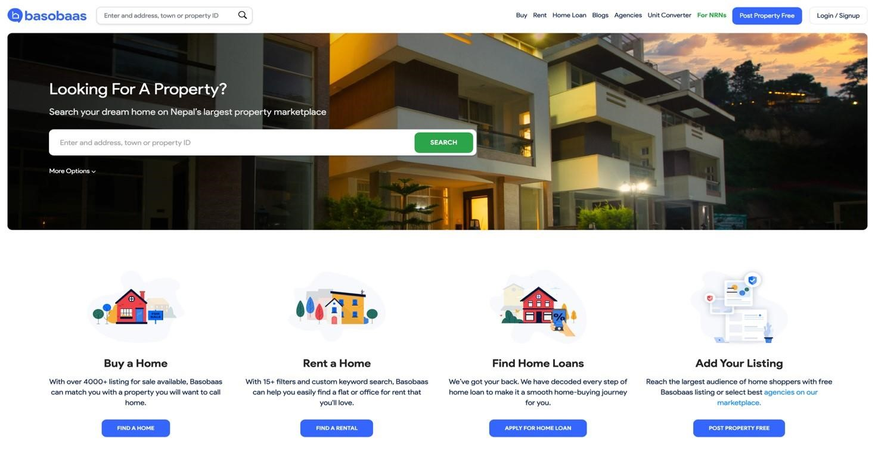

*Figure 1: Basobass*

**Reality Nepal:** Realty Nepal is another well-known real estate website in Nepal. The website is divided into parts, each of which has unique characteristics. It has a search feature that lets users use keywords to look for houses and properties. Additionally, properties are displayed by location, allowing guests to look at several possibilities in a particular area of interest. In order to gain access to the entire system, users can register on the website. There is also a "News" section with a variety of news articles about real estate. The website shows the location of a property on a map and all pertinent property information when you see it.

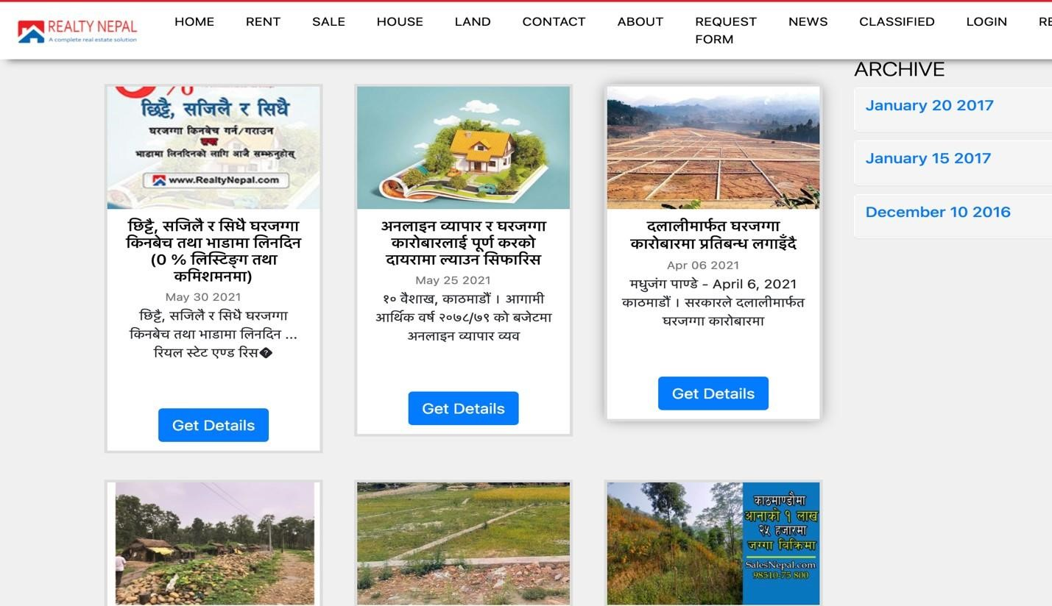

*Figure 2: Reality Nepal*

**Trulia:** One of the best real estate websites, Trulia is renowned for its elegant and incredibly user-friendly interface. In addition to browsing choices for purchasing, renting, and seeing properties, users can investigate recently sold properties. The app offers a link to further mortgage information and shows houses according to geography. With seamless page navigation, any property that fits the user's search parameters is displayed both on a map and in a list style. Additionally, users can use a number of variables to narrow down their search. The website provides thorough property listings that include details about the house and its surroundings. Users can also store homes on their "Saved Homes" tab for convenient access in the future.

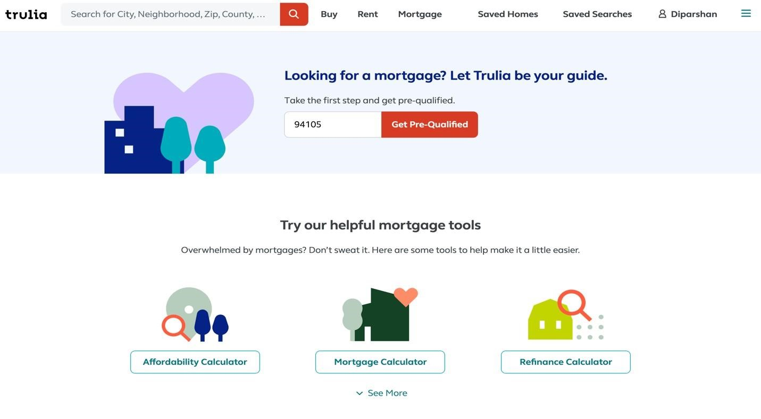

*Figure 3: Trulia*

**NepalHomes:** NepalHomes, one of the top real estate websites in Nepal, is commended for having an attractive and easy-to-use interface. In addition to financing and real estate marketing services, the platform provides a range of choices for property rentals and purchases. The website has a "News" section that compiles the most recent information about various events, and users can use the search box to look for properties. Users have the option to sort postings while looking for properties according to various parameters. The website also features a recommendations section where visitors can find suggestions for more homes.

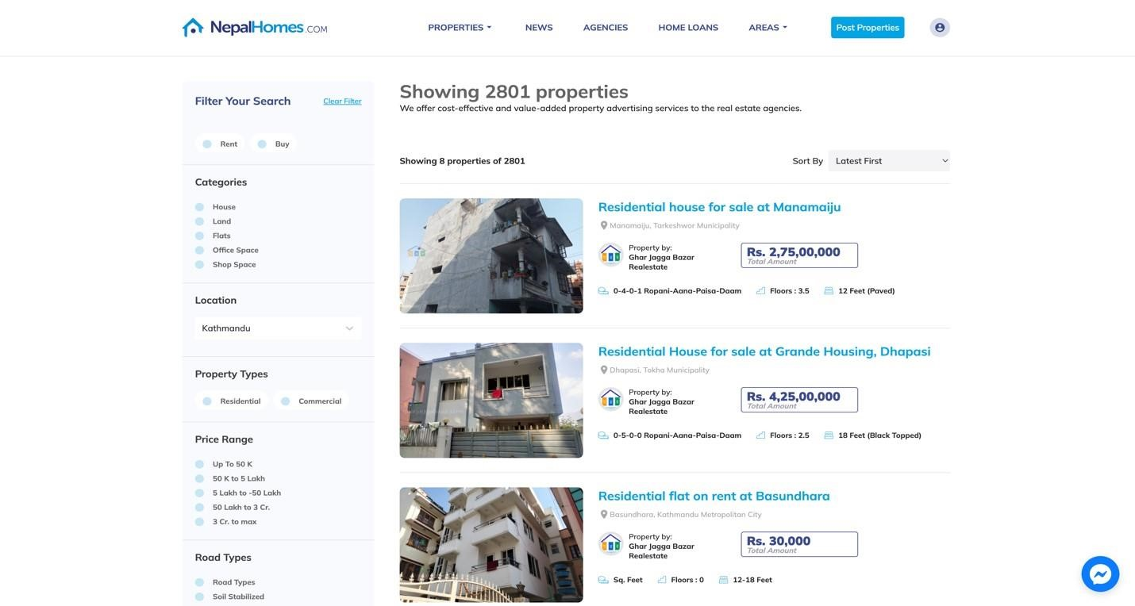

*Figure 4: NepalHomes*

**Rentals:** Rentals is another excellent global real estate website. The search bar allows users to look for houses and properties by location. Users can see the property's precise location thanks to Google Maps integration. Landlords and tenants have different registration requirements. Additionally, the website has a "Blog" area with a variety of educational topics. The location of the property on the map is shown when viewing it, along with any pertinent information, giving consumers a thorough rundown of the listing.

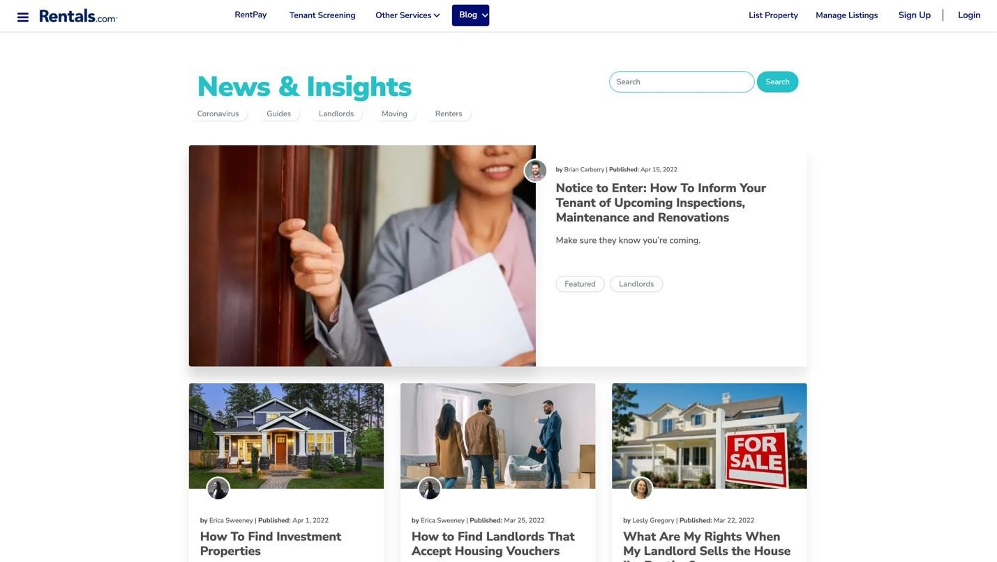

*Figure 5: Rentals*

##### Similarity Check

|  |  |  |  |  |  |
| --- | --- | --- | --- | --- | --- |
| Features | Basobaas | | Reality Nepal | Rentals | comparison (my website) |
| Attractive UI |  | **Yes** | **No** | **Yes** | **Yes** |
| Easy navigation |  | **Yes** | **Yes** | **Yes** | **Yes** |
| Blog section |  | **Yes** | **Yes** | **Yes** | **Yes** |
| Booking |  | **No** | **No** | **No** | Yes |
| Map |  | **No** | **No** | **Yes** | Yes |
| Display list property | of | **Yes** | **yes** | **Yes** | **Yes** |
| Search feature |  | **Yes** | **Yes** | **Yes** | **Yes** |
| Notification |  | **Yes** | **No** | **Yes** | **Yes** |
| User-Profile |  | **Yes** | **Yes** | **No** | **Yes** |

*Figure 6: Similarity Check*

#### 2.3 Artefact (Proposed): Home Rental System

##### 2.3.1 WBS

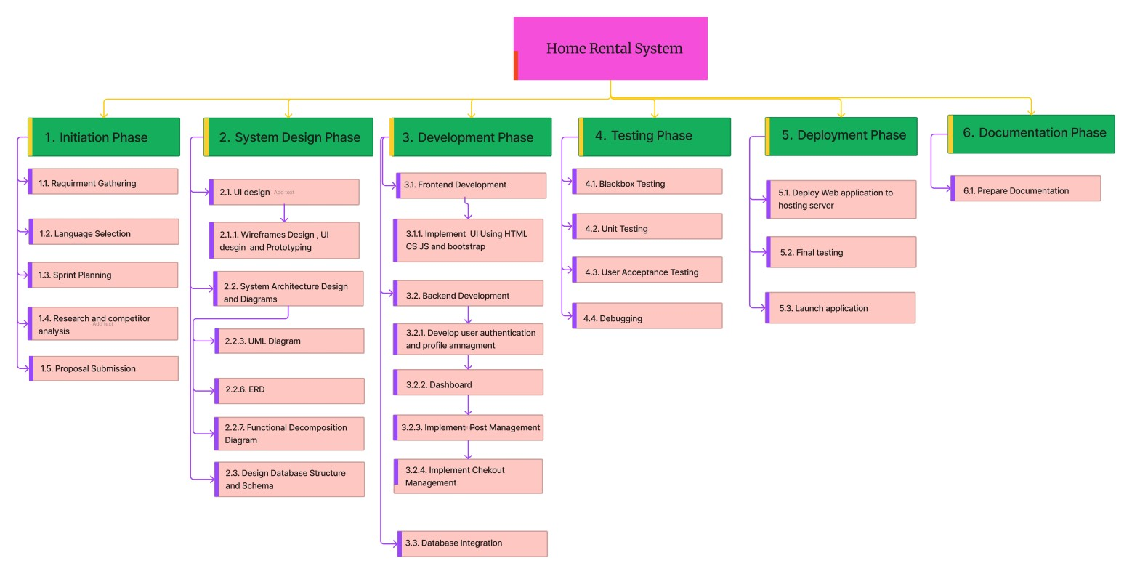

*Figure 7: WBS*

##### 2.3.2 Overview

Modernizing Nepal's housing leasing process is the goal of the innovative web platform known as "home rental system." For landlords, it provides effective property search, digitalized documents, open communication, and user-friendly tools. It prioritizes user input, scalability, and data security and was developed using Scrum. In the end, the technology transforms rental management and improves the experience for both tenants and landlords.

##### 2.3.3 Justification and Relation to Academic Question

Effective property searches in the rental application depend on the use of powerful

search and filtering tools. These features provide a competitive edge, improve user experience, and save time. It encompasses front-end programming, database management, user experience optimization, data structures, algorithms, user-centered design, and user interface design. These abilities guarantee a platform that is userfriendly, efficient, and competitive while adhering to contemporary software development norms.

##### 2.3.4 Consideration of Other Artefacts

The Nepal Rental - Web Application was developed after thorough research on related projects. It will blend distinctive elements from related projects in order to fulfill client objectives and exceed expectations. This strategy guarantees a customized solution that stands out and connects with customers.

##### 2.3.5 Full Details of the Artefact

The following are the main elements that will make up the Home Rental System platform:

**View Blog:** Both registered users and people from across the world can utilize this service. User can view the list of blogs that the administrator has uploaded in the feature.

**User registration and login:** To utilize the system to its fullest, a user must first register. After successfully enrolling, the user needs to log in to the system in order to access it.

**View and update profile:** Users are able to view their profiles using this function. Using this function, registered users can change their name and email in their profile.

**Upload property:** Users can add their property to the application using this functionality. Users are able to post photographs that are linked to their property, as well as details like the price and description.

**Notifications:** Both the user and the property owner will receive notifications regarding the booking information following the user's successful reservation of the property.

**Add to cart:** Additionally, logged-in visitor have the option to add various properties to their shopping cart for later viewing and booking.

**Filter property:** With this function, users can filter a list of properties according to the category they have chosen.

**Property Listings and Uploads:** Landlords can upload rental property details, including descriptions, pricing, images, and amenities, making properties visible to potential tenants.  
  
**Booking and Application Management:** Tenants can book properties directly from the platform, submit rental applications, and receive real-time updates on their application status.

**Payment Tracking and Management:** Facilitates secure payment processing for rents and deposits while keeping records for both parties for transparency and accountability.

**Rental Agreement Management:** Provides a digital solution for generating, storing, and signing rental agreements to reduce paperwork and improve convenience.

**Automated Chatbot 24/7**: With this function, users can get instant assistance for their queries at any time of the day. The chatbot provides answers to frequently asked questions, helps navigate the website, and resolves common issues without the need for human intervention.

**Application Status Tracker**: With this function, users can track the progress of their rental applications. It updates them on key milestones, such as application submission, verification, approval, or rejection, ensuring transparency and ease of access.

**Maintenance Request**: With this function, users can submit requests for property maintenance directly from the platform. It allows tenants to report issues such as plumbing or electrical faults, ensuring timely action by the property management team.  
  
**Arranging for Necessary Repairs**: With this function, property managers can coordinate repair work for reported issues. They can contact service providers, schedule repair visits, and ensure the job is completed efficiently, maintaining property quality.  
  
**Premium Maintenance**: With this function, users can opt for advanced maintenance packages. These packages include periodic inspections, proactive repairs, and other premium services to ensure the property remains in excellent condition.

##### 2.3.6 Development Approach

The project will use the Scrum technique, which divides the development process into manageable sprints with iterative work cycles. The project team will work closely together, holding regular meetings to monitor progress, collect user feedback, and rank features in accordance with both user preferences and project goals. This strategy guarantees a flexible and dynamic development process, encouraging rapiadvancement

and the best results.

##### 2.3.7 Methodology Justification

Scrum was selected as the development approach due to its adaptability to changing requirements, transparency, and flexibility. Because of its iterative methodology, the development team can consistently produce functional platform increments, guaranteeing ongoing enhancement and the capacity to adapt to input and evolving requirements as the project progresses..

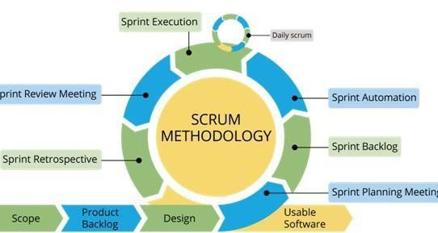

(Agile Arena, 2020)

*Figure 8: Scrum Methodology*

##### 2.3.8 Tools and Techniques

For the "Home Rental System" platform's development, Django will serve as the backend basis, and the frontend will be composed of HTML, CSS, and JavaScript. Visual Studio Code (VS Code) will serve as the integrated development environment (IDE), and Figma will be used for wireframing and design collaboration. Version control will be kept up to date using Git, ensuring efficient work and code management.

##### 2.3.9 System Testing

**Unit Testing**: As a fundamental approach in software development, unit testing entails testing distinct pieces of code. It guarantees that these parts work as planned and deliver desired results. Early bug detection helps to cut down on the expenses and difficulties of more involved repairs.

**User Acceptance Testing**: User Acceptance Testing (UAT) is an important stage in the development of software for a number of reasons. It makes that the software satisfies user needs, identifies defects and usability problems, and confirms that it is in line with actual situations and business procedures. UAT raises user satisfaction, lowers deployment risks, and increases trust in the deployment of software. UAT supports usercentered, effective software development and deployment by involving end users and validating training materials.

**Performance Testing**: Performance testing guarantees that software systems can manage heavy workloads, react quickly, efficiently utilize resources, and remain stable. It establishes benchmarks, facilitates planning, raises user happiness, and averts expensive problems. It ensures a smooth user experience and good system performance.

**Integration Testing**: Integration testing guarantees that components communicate clearly, finds errors, authenticates data flow and interfaces, lowers risks, and increases confidence. It guards against problems, encourages economical development, and guarantees a successful deployment.

**3. Plan/Schedule**

#### 3.1 Gantt Chart

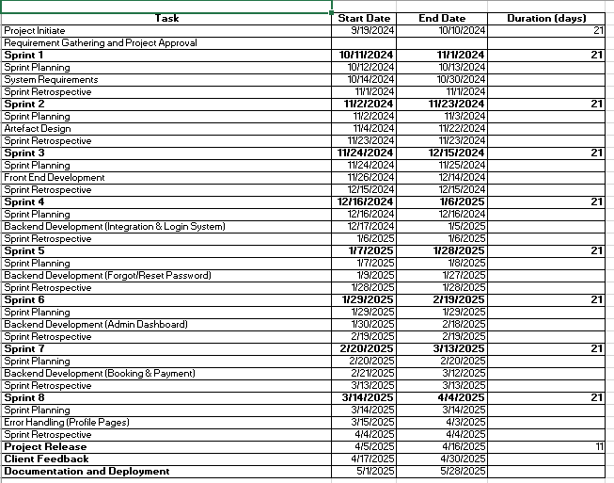

*Figure 9: Gannt Chart*

**References**

Basobas, 2016. *Basobas.* [Online] Available at: https://basobaas.com/

Ert, E., 2019. Annals of Tourism Research. *The evolution of trust in Airbnb: A case of home rental,* 75(10), pp. 279287.

Gilbert, A., 2016. Habitat International. *Rental housing: The international experience,* 54(3), p. 186.

Nepal Homes, . *Nepal Homes.* [Online]

Available at: https://www.nepalhomes.com/

Schwaber, K., 2017. Business Object Design and Implementation. *SCRUM Development Process,* p. 555.

Truila, 2023. *About US.* [Online] Available at: https://www.trulia.com/